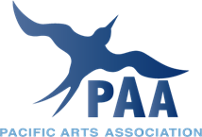 - EUROPE

Scholarships for Participation at the Annual PAA-E Meeting

Musée du quai Branly – Jacques Chirac, 13-15 September 2022

The Pacific Arts Association-Europe is offering up to two annual scholarships to support the participation of Pacific artists, students or scholars at the annual PAA-E conference. The scholarship is for a maximum of € 300; it pays in addition the cost of the conference fee and the conference dinner.

Eligibility:
Pacific artists, students and scholars who propose a contribution to the annual PAA-E conference that is accepted by the conference organiser.

Requirements:
- Write a short statement (max. 200 words) explaining why attending the PAA-E meeting is important for you.
- Propose a paper, report or performance to be presented at the conference.
- Provide name and details of one external referee. Applicants should contact their referee directly and ensure the reference is sent to the Scholarship Committee by the closing date.

Applications, including a proposal for a presentation at the conference, should be sent to the PAA-E Scholarship Committee (ach13@cam.ac.uk) by the closing date of 31 July 2022 Applicants will be informed of the outcome within two weeks of the closing date.

